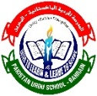

Pakistan Urdu School- Kingdom of Bahrain Primary Section

Social Studies- Grade -1

Topic: Keeping clean

Class Activity

Name: ______________________________ Class & Sec: __________________________

**Draw and name any five things that we use to keep ourselves clean.**

|  |
| --- |
|  |
|  |
|  |
|  |
|  |